OTT-PLATFORM
The project report submitted as a part of Industrial Training program under:
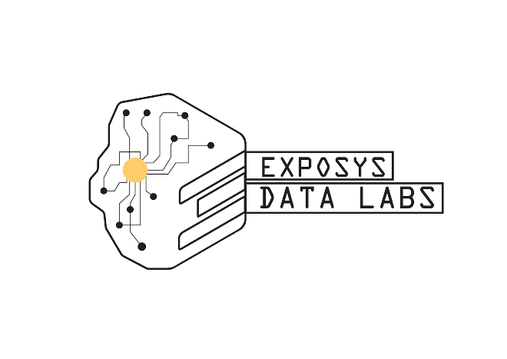

On
WEB DEVELOPMENT (FRONT-END)
Submitted By:

P RAJESHWAR REDDY (160118735039)

CHAITANYA BHARATHI INSTITUTE OF TECHNOLOGY


Under the Noble Guidance of:
Aravind

Table of Contents: -

- Abstract ---------------------------------------- 2

- Introduction -----------------------------------3

- System Requirements ----------------------6

- System Architecture ------------------------7

- Implementation -----------------------------8

- Conclusion & Future Scope---------------19

- References -----------------------------------20

Abstract: -
Today we are going through a period of lock-down which the people of India have never seen before, for such a long time. In such a situation, in the era of this technology and the Internet, anyone likes to spend their free time in front of the digital screen, where they have many options to see. The ever-increasing viewership of the OTT video streaming services and the big star's inclination towards this platform justifies this. Today, the time we spent looking at our screens has increased immensely. As the cinema halls shut and film release has been suspended amid nationwide, this technological shift by internet has created a new kind of viewing experience and that might end up changing the collective movie watching experience in cinema hall.

Introduction: -

Over the past two decades, there has been a monumental shift in how people access and consume video content. With the universal access to broadband internet, numerous platforms like YouTube, Netflix, HBO Go emerged and steadily grew to prominence. These platforms became successful by catering to media-hungry audiences and fitting around their increasingly hectic lifestyles.
The ages-old TV-watching experience is no longer limited to real-time nor the TV screen in the living room. Content is now consumed on laptops, tablets, handheld devices, game consoles – whenever and wherever people like.
Although not a household name in itself, OTT is the exact technology that made the streaming revolution possible. In this article we shed some light on the term, provide examples of the leading OTT platforms and explore the emerging possibilities the market offers.
What is OTT?
In general, depending on who you ask, there is usually a certain lack of consensus regarding the definition of OTT. Operators, hardware manufacturers and OTT platforms – as well as their audiences – see things differently and have other things in mind as far as OTT is concerned.
While we know the acronym OTT stands for Over The Top, there is a bit of controversy regarding what it really means:
By most definitions known today, OTT simply refers to any video streaming service delivering content to the users over the internet. Originally, this happened alongside (or usually on top of) a traditional platform like cable TV, hence ‘over the top’. An example here is HBO Go, which in many countries was only offered as a bonus for HBO cable subscribers. This restriction no longer exists today.
OTT could also refer to the subscription model whereby the platform (e.g. Netflix) charges the fees on top of what you’d have to pay to your ISP or cable provider… Or allows you to avoid the fees of the operator (i.e. WhatsApp is a great example here, giving its subscribers the convenience of “free” “SMS” service using their internet connection. This definition would make WhatsApp an OTT platform).
While OTT is commonly used to denote video content, many audio services fit this definition just as well. Spotify is to music what Netflix is to TV – offering a massive trove of music via the internet connection.

What are OTT Platforms?
OTT is no longer an experiment or an internet geek’s fancy. Today, television is increasingly delivered over the internet and new media companies are joining the race towards market dominance. Netflix has been around for so long you might think its market position is unflinching. But it’s still not too late for new players to try to establish their market presence. The successes of Disney+ launched only last year but managed to exceed 28 million subscribers already.
OTT also enables access to live streaming. These work much like channels in regular TV, but the content is streamed using the Internet connection to the audience’s OTT devices / set-top boxes.
What are the opportunities of OTT?
The revenue generated by over the top (OTT) media is expected to reach 158.84 billion dollars by 2024. This is more than twice the 67.8 billion generated in 2018. In general, OTT has grown massively over the eight years, with revenues growing exponentially from 6.1 billion U.S. dollars in 2010 to over ten times that amount in 2018.
Today, the OTT industry is booming as the technology has become a dominant channel for video consumption alongside PayTV and traditional broadcast services. With a 28% Year-on-Year growth in total time spent streaming on OTT, the media revenue is expected to reach 158.84 billion dollars by 2024, more than double the 67.8 bn generated in 2018 (source: Statista).
The US SVOD market is one of the biggest in the world. It is expected there will be a dozen OTT platforms with more than 5 million paying subscribers by the year 2025.
Growth for the big players such as Amazon Prime and Netflix is bound to slow down due to intense competition from younger rivals such as Disney+ and Peacock TV. This also explains the increasingly evident content license tug-of-war going on and an increased push to produce original content – like Netflix does.

Advertising
OTT is not only a booming outlet for content providers. It’s also the advertisers’ cornucopia. Among other things, it solves some of the biggest problems with traditional TV – lack of precise targeting and attribution. The traditional TV commercials followed the “spray and pray” method. This made all advertising efforts incredibly hit or miss – it was almost impossible to measure the actual effect of the campaigns. This process is now much more streamlined and efficient in OTT.
Ad audiences in the OTT space can be precisely built and targeted super-personalized ads. This gives advertisers robust possibilities to quantify the impact and calculate ROI more accurately.
OTT services which operate on a paid subscription basis can also run ads. With tiered packages, they can allow viewers to decide whether they’re more after ad-free experiences or free, but ad-supported access.

OTT vs IPTV vs SVOD: One and the same?
With the growing number of three-letter streaming-related acronyms, it may be hard sometimes to gain a better understanding of the landscape. Specifically, there is a common confusion between OTT, VOD and IPTV.
IPTV is television delivered using Internet Protocol (which explains the “IP” in IPTV). The video streams are usually delivered within a private network and are accessible only from devices (set-top-boxes) issued by the operator. Verizon FiOS or AT&T U-verse are examples of IPTV services.
VOD – video on demand typically involves paying for each piece of content individually.
Subscription-based video on demand services (SVOD), like traditional cable TV subscriptions, allows users to watch as much content as they want at a flat rate per month. Major services include Sky (plus its subsidiary Now TV), Amazon Prime Video, Netflix, and Hulu.

System Requirements: -

Hardware Requirements:

➢ Hard Disk - 1TB

➢ RAM – 8GB

➢ Processor – Core i5

Software Requirements:

➢ Operating System - Windows 10-64bit

➢ Markup language - HTML5

➢ Language – CSS3

➢ Framework – Bootstrap5

System Architecture: -

Payment
Gateway
Subscription
Homepage
TV Series
Movies

Implementation: -

Modules:
➢ User Module
➢ Home Page

User Login:
The user module allows users to register, log in, and log out. Users benefit from being able to sign on because this associates content they create with their account and allows various permissions to be set for their roles. The user module supports user roles, which can be set up with fine-grained permissions allowing each role to do only what the administrator permits. Each user is assigned one or more roles. By default there are three roles: anonymous (a user who has not logged in) and authenticated (a user who is registered), and administrator (a signed in user who will be assigned site administrator permissions). Users can use their own name or handle and can fine tune some personal configuration settings through their individual my account page. Registered users need to authenticate by supplying their username and password, or alternately an OpenID login. A visitor accessing your website is assigned a unique ID, the so-called session ID, which is stored in a cookie. For security's sake, the cookie does not contain personal information but acts as a key to retrieving the information stored on your server.

HTML:
HTML is the standard markup language for creating Web pages. HTML stands for Hyper Text Markup Language. HTML describes the structure of Web pages using markup. HTML elements are the building blocks of HTML pages. HTML elements are represented by tags.

CSS
Cascading Style Sheets (CSS) is a style sheet language used for describing the presentation of a document written in a markup language.

JAVA-SCRIPT:
JavaScript is a lightweight, interpreted programming language. It is designed for creating network-centric applications. It is complimentary to and integrated with Java. JavaScript is very easy to implement because it is integrated with HTML. It is open and cross-platform.

Bootstrap:
Bootstrap is a free and open-source CSS framework directed at responsive, mobile-first front-end web development. It contains CSS- and JavaScript-based design templates for typography, forms, buttons, navigation, and other interface components.

Results:

Signup Page:
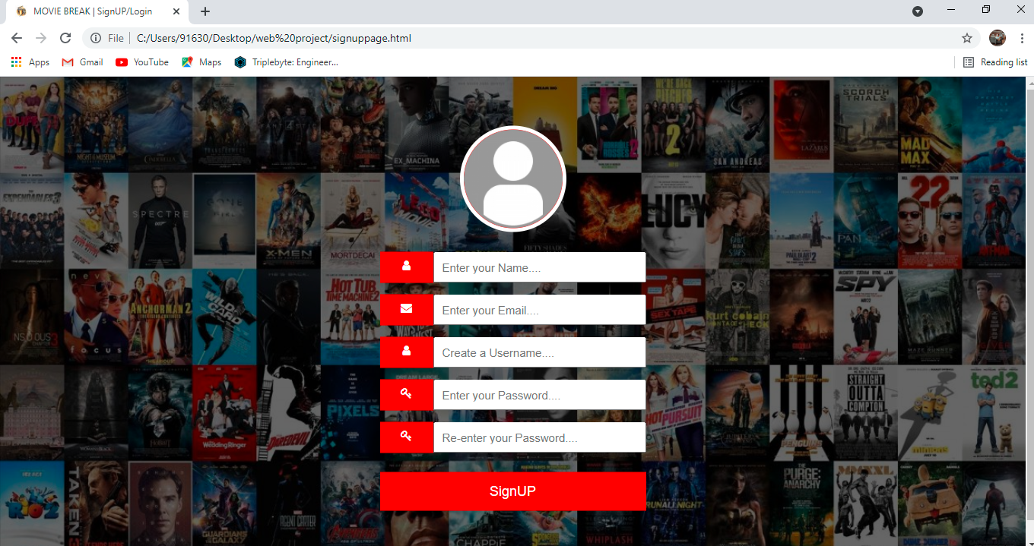
This screen will help user to generate new Username according to their wish and user will also create new password and same will be confirmed again. User will enter captcha for verification and will click on submit button to final submit. This Snapshot 1: Signup page screen will also help user to create password that is defined in the system. Password policy will also display side by side.
Snapshot-1: Signup Page
Login Page:

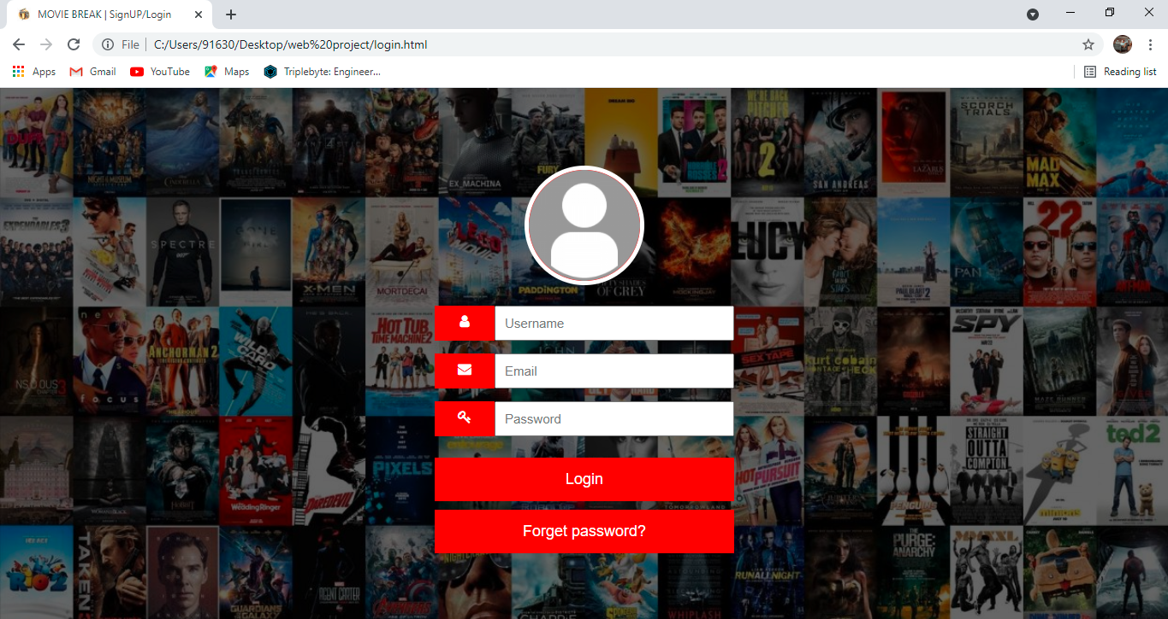
The Login Module is a portal module that allows users to type a username and password to log in. You can add this module on any module tab to allow users to log in to the system. If you allow users to create accounts and turn on Portal Direct Entry, a Create Account link appears in the Login Module.
Snapshot-2: Login Page

Homepage:

A home page is generally the primary web page a visitor navigating to a website from a search engine will see, and it may also serve as a landing page to attract visitors. Thus good home page design is usually a high priority for a website. Here we are having different modules were we are going to explore over homepage.
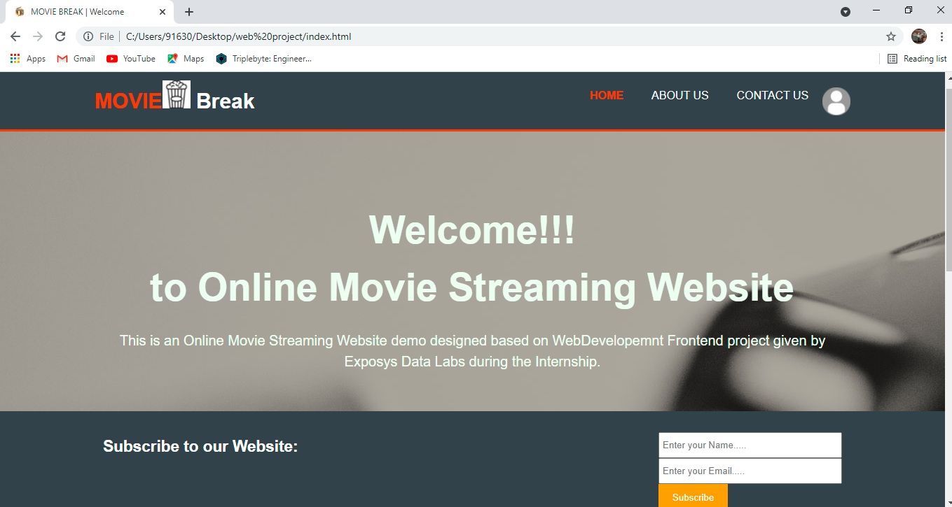
Snapshot-3: Homepage

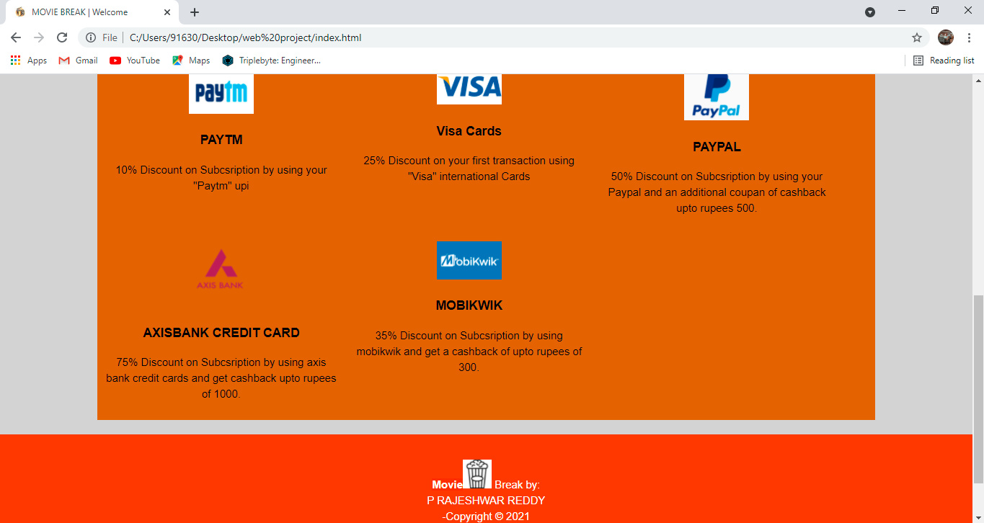
Snapshot-4: Homepage continuation

Even the home pages are having long scroll effects and it has more effects to engage users. The advantage of not having to click “next” keeps users engaged with the content and less focused on the mechanics of navigating to the next page. Snapshot 4: Homepage Continuation It translates well to mobile devices. The increased use of mobile screens has played a key role in the widespread acceptance of this technique: The smaller the screen, the longer the scroll. The gesture controls of mobile devices make scrolling intuitive and fun.
About us:
An About Us page is your chance to tell the world:
- Who you are?
- What matters to you.
- What you do.
- How you do it.
It’s often one of the first stops when someone visits your website or blog.
An About Us page may be a deciding factor before you convince someone to convert, whether that comes in the form of:
- Making a purchase.
- Downloading an awesome piece of content.
- Signing up for your newsletter.
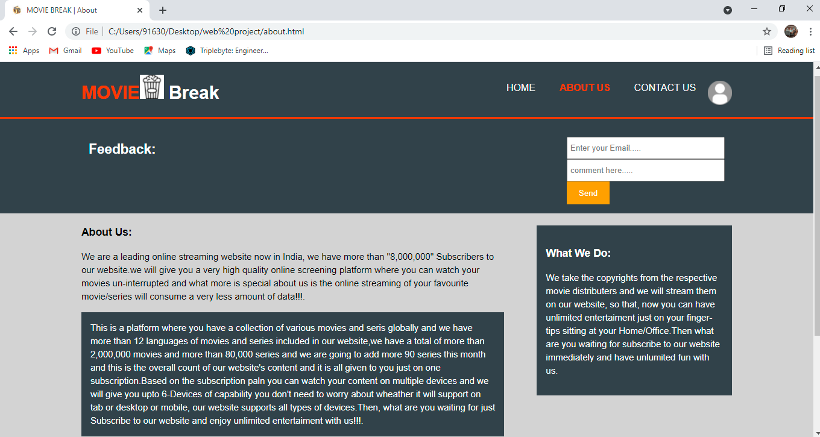
- Requesting information or a demo.
Snapshot-5: About Us Page
Contact Us:
They explain why a visitor should contact you and describe how you can help to solve your visitors' problems. They include an email and phone number so that the visitors could quickly find the required information. They include a short form that uses fill that will help you understand who's contacting you.

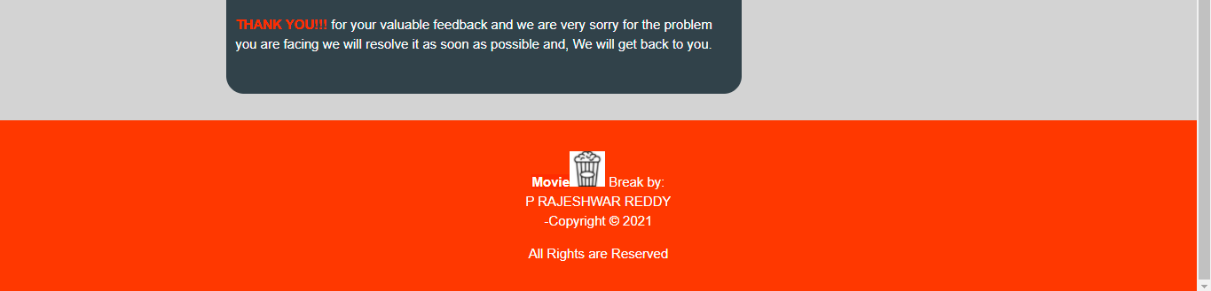
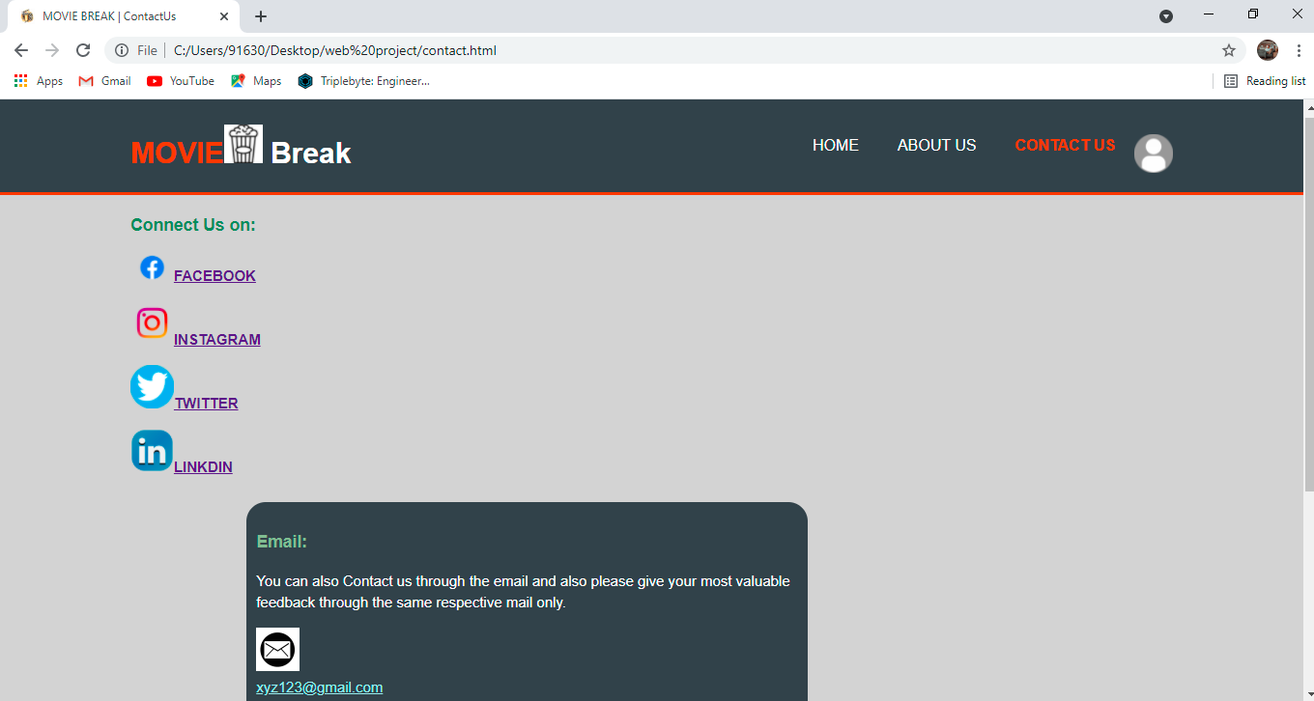

Snapshot-6: Contact Us Page

Subscription Page:
A subscribe page usually consists of a short form that a visitor to your website can fill out to subscribe themselves to one or more of your lists. But here we have included the packages cost where a customer can select any of the given packages as per his/her need.

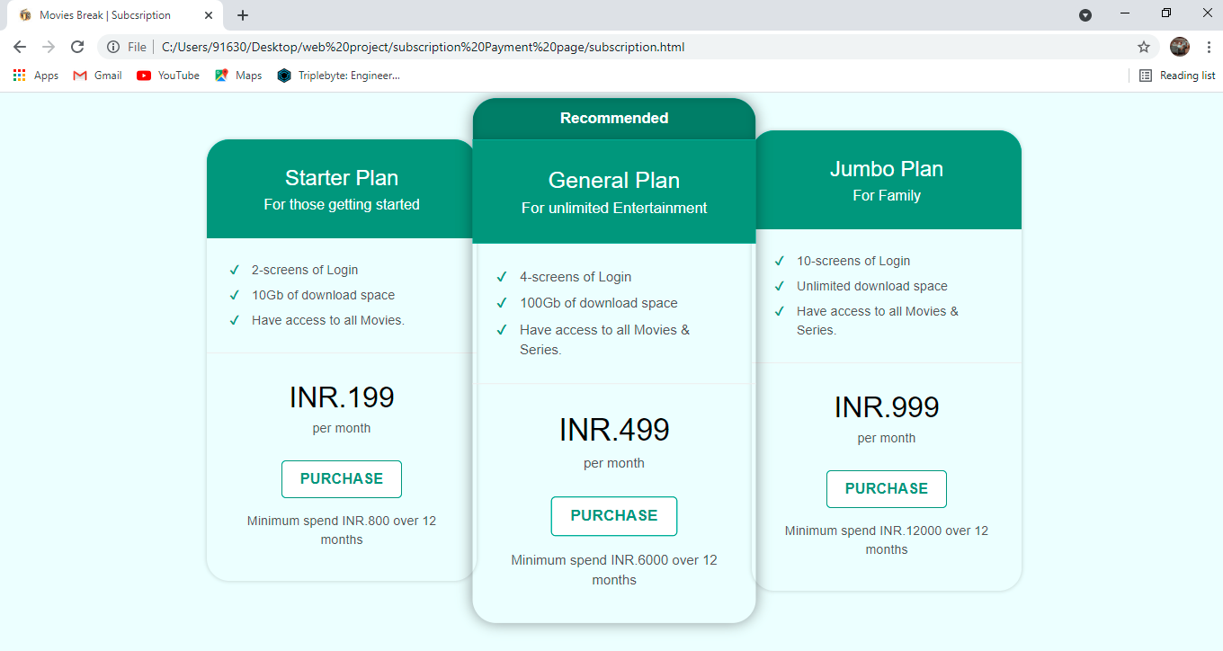
Snapshot-7: Subscription Page

Payment Page:

The payment page is a web page that allows customers to purchase items easily and securely. ... The payment pages involve the data about the holder of the account i. e. first and last name, email along with phone number, and card number along with the expiration period.

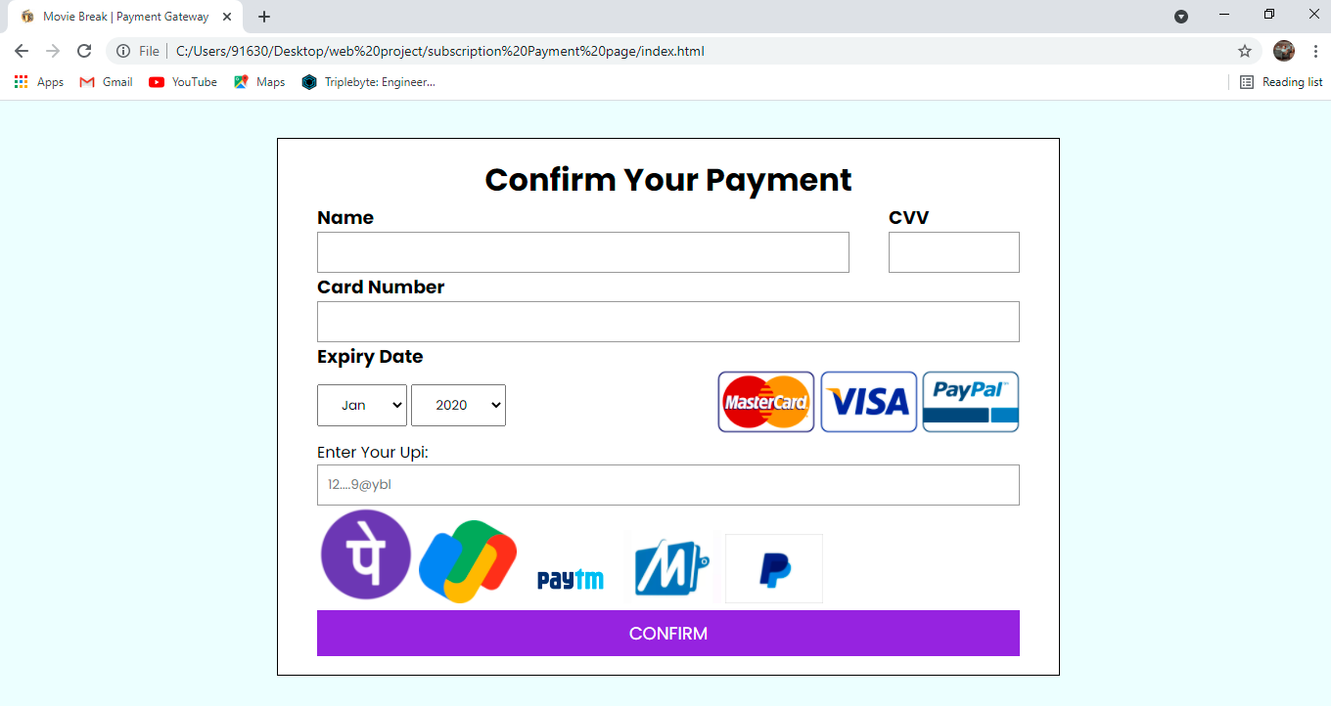
Snapshot-8: Payment Page

Movies Page:

Movies are made to entertain audiences, and movie websites are much the same. In order to get visitors’ attention and encourage them to see the movie, a website needs to give them what they are looking for and provide some entertainment at the same time. Today’s movie websites make it easy to take a couple minutes and watch a few trailers before deciding which movie to see.
Because the purpose of movie websites is to pique interest and sell tickets, they generally include:
- Plenty of video, including trailers,
- Easy access to show times and online ticket purchasing,
- Cast bios and other general info.

- Modes Of screen:

*Dark Mode:
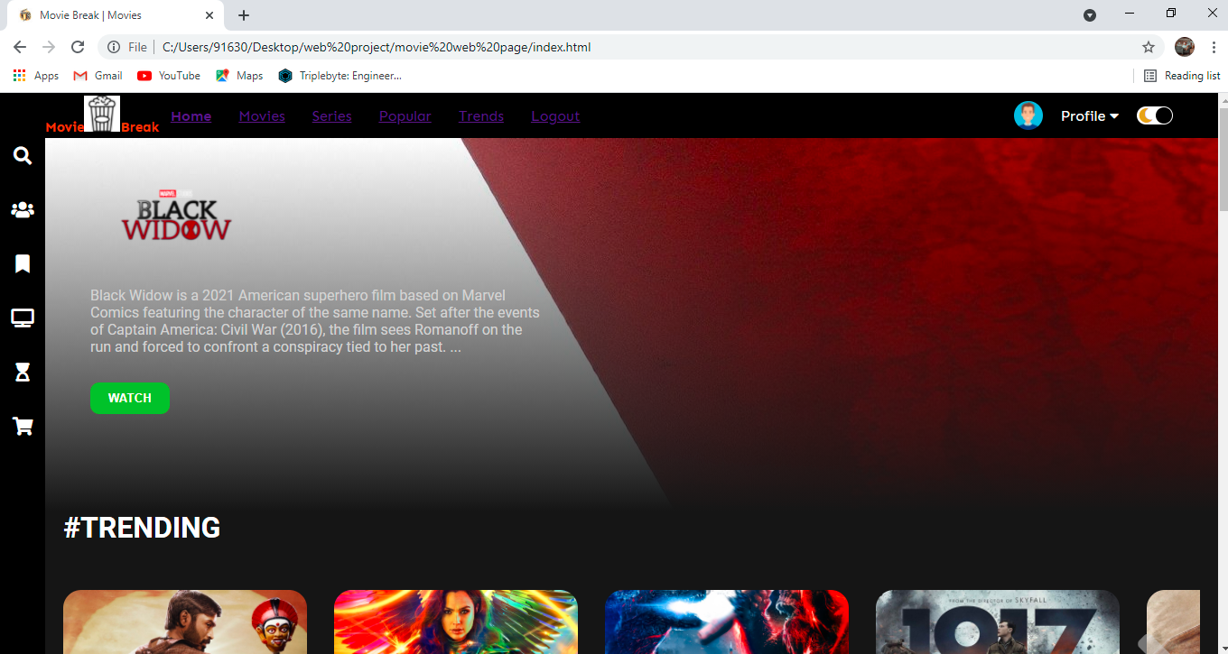
Dark mode is a display setting for user interfaces, such as a smartphone or laptop. It means that, instead of the default dark text showing up against a light screen (known as 'light mode'), a light colour text (white or grey) is presented against a dark or black screen.

*Light Mode:
It means that, instead of the default dark text showing up against a light screen (known as 'light mode'), a light colour text (white or grey) is presented against a dark or black screen. Light mode, however, is the default setting for most phones and apps.
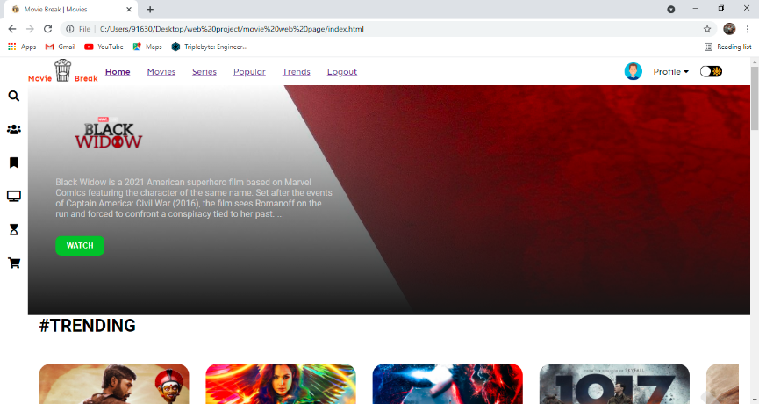

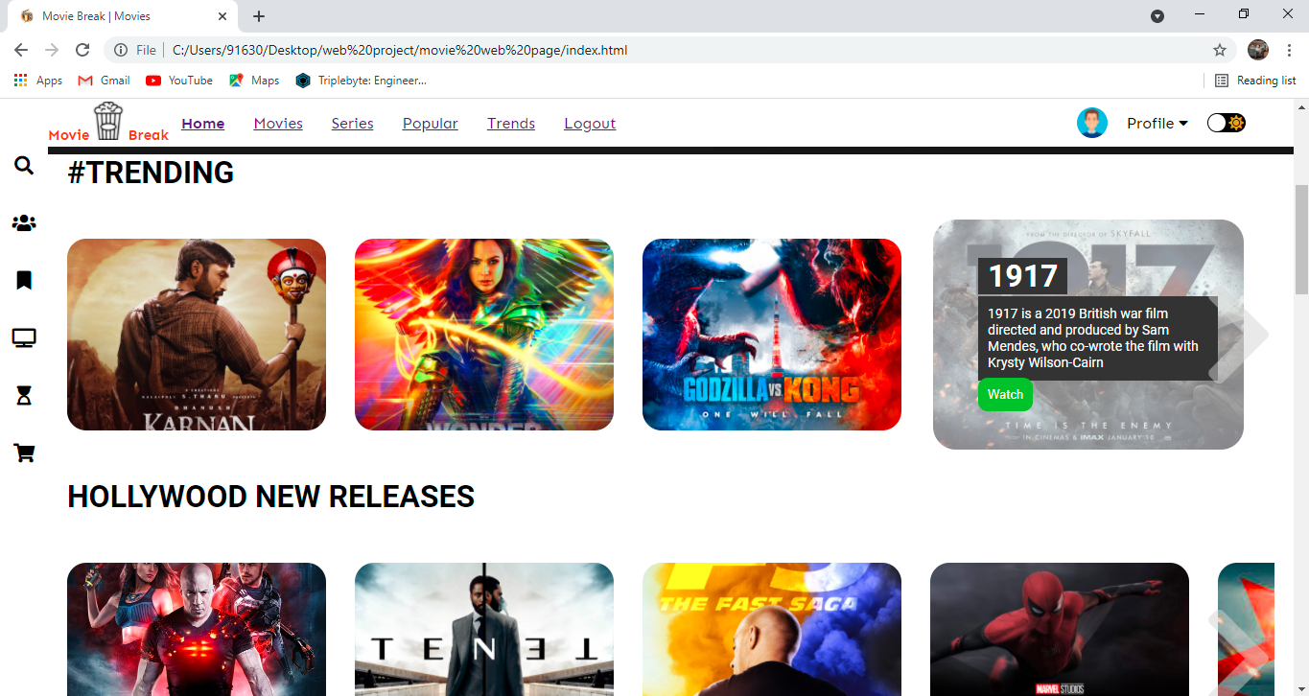
- In the movie page when we place cursor on the particular movie poster we get a small description of the movie and the we can also see the watch button as shown below in the snapschot-9.
Snapshot-9: movies poster Hovering&description

- TV-series:
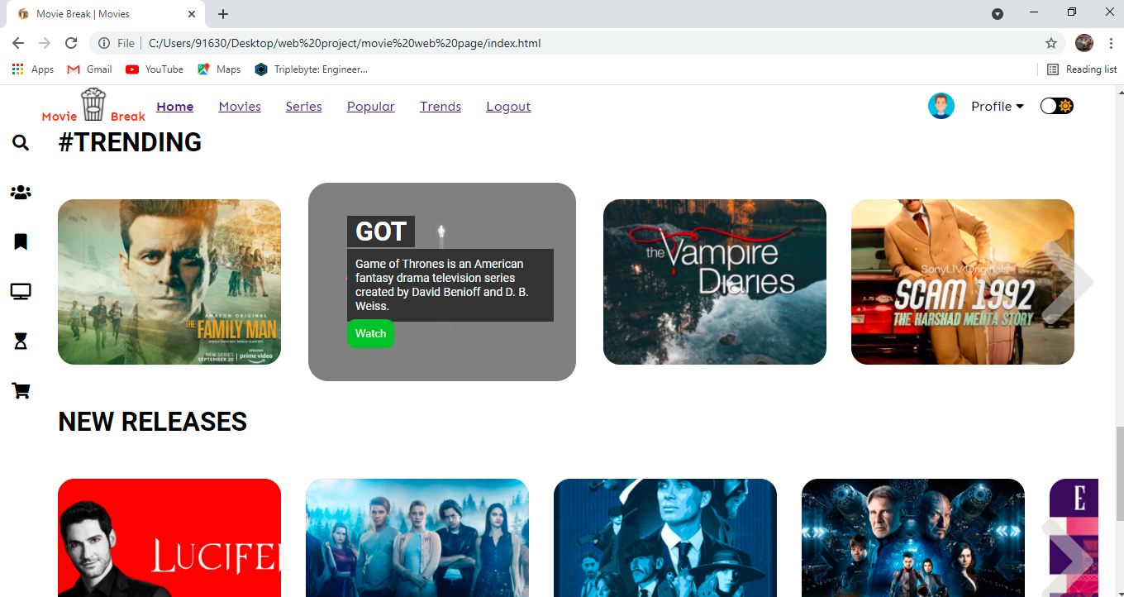

Snapshot-10: Tv-series
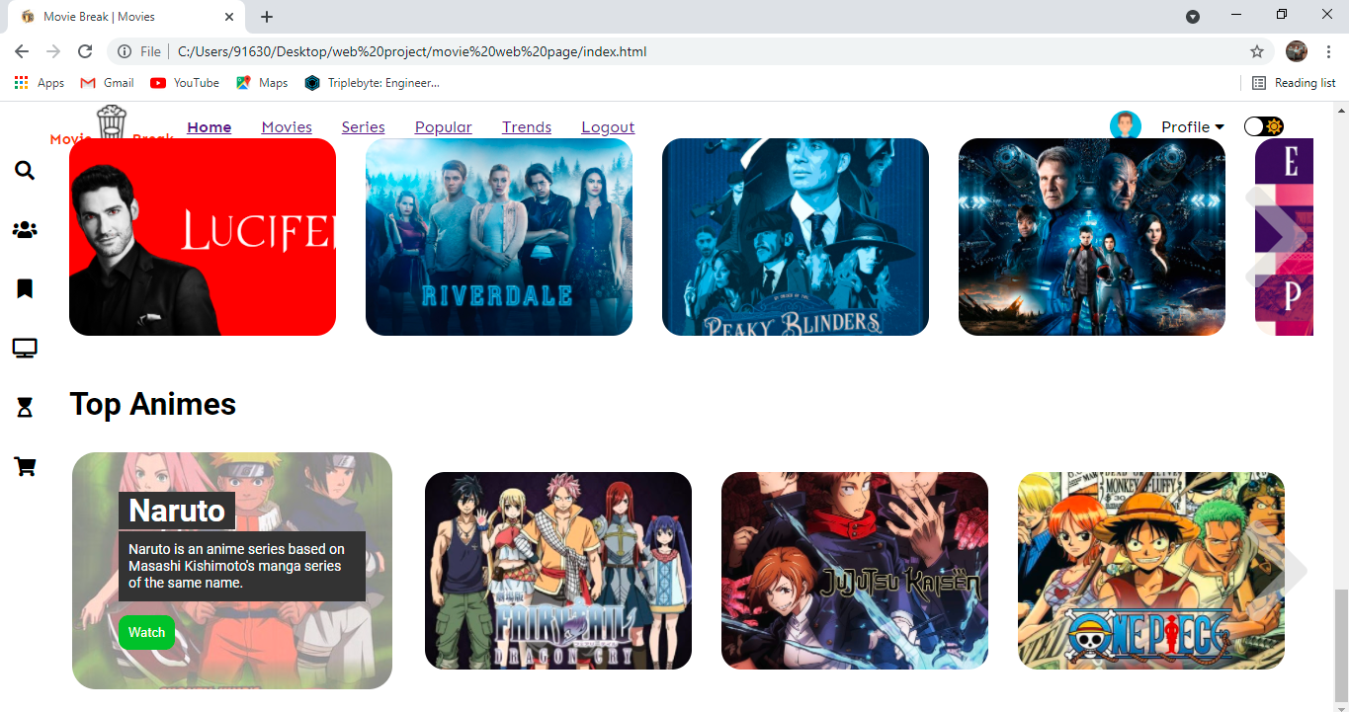
- Top-Anime:
Snapshot-11: Top Anime

Conclusion & Future Scope:
Online movie streaming is the growing business in India and due to the lockdown & corona effect in India as the theatres are closed because of the mass public gatherings have been prohibited by the government as per corona regulations so, lot of people started using the OTT apps for their personal entertainment.
- Scope of OTT Platform/ VOD Platform
The biggest OTT platform or VOD platform services in India include Hotstar, Amazon Prime, Netflix, Eros Now, Sony LIV, ALTBalaji, and Zee5. Some of the key statistics related to OTT consumption in the country are as follows:
Counterpoint Research reports that 89% of viewers in India are under 35
India’s 5 metropolitan cities account for 55% of all its OTT viewers, which means there is a massive untapped market that will fuel massive growth in the future
Hotstar is the market leader in the Indian OTT market, as it has 300 million active users and 8 million paid subscribers
Eros Now recorded the largest number of Smart TV viewers
Xiaomi accounted as the most popular mobile device brand for viewing OTT content
Around 2 in 3 people from the top 5 metropolitan cities consumed content on Amazon Prime and Netflix
As already mentioned, Hotstar is the biggest OTT platform in India in terms of the number of users. It is a subsidiary of Walt Disney and covers multiple languages and TV channels. It stands out for providing some of the highest-rated and longest-running TV content in the country.
Netflix is a relatively expensive OTT service provider in this market. However, it still offers more affordable plans that provide SD quality content on mobile devices. Interestingly, Netflix has stuck to the policy of keeping its user-base a secret in this market.
Amazon Prime Video, a major OTT or VOD platform in India, is a relatively affordable service provider. It provides viewers access to a vast library of content, 4K quality and unlimited downloads. Besides, its video-on-demand services also come packaged with its premium Amazon services and special deals for Prime Music.

References: -

https://www.uscreen.tv/?via=adam-enfroy

https://setplex.com/en/?utm_source=adamenfroy&utm_medium=referral&utm_campaign=bestOTTplatform

https://www.ibm.com/watson/media/ott-video-management-platform-and-services

https://www.netflix.com/in/

